Custom MapReduce with Hadoop Streaming for Online Food Delivery Analytics

Project Objective

Analyze online food delivery transactions using Hadoop Streaming to:

Find city-wise revenue

Identify top-selling food items

Analyze monthly revenue trends

Determine average order values

Visualize business insights using Python

Part 1: Generate Food Delivery Dataset

nano generate_food_orders.py

import random
import datetime

foods = [
"Pizza", "Burger", "Pasta", "Sandwich",
"Biryani", "Noodles", "Fries", "Momos"
]

cities = [
"Mumbai", "Delhi", "Bangalore",
"Chennai", "Hyderabad", "Pune",
"Ahmedabad", "Kolkata"
]

customers = [
f"CUST{str(i).zfill(5)}"
for i in range(1, 2001)
]

start_date = datetime.date(2025, 1, 1)
end_date = datetime.date(2025, 12, 31)

days = (end_date - start_date).days

print("Date,FoodItem,Price,City,CustomerID,Quantity")

for _ in range(60000):

date = start_date + datetime.timedelta(
days=random.randint(0, days)
)

food = random.choice(foods)

price = round(
random.uniform(80, 1200),
2
)

city = random.choice(cities)

customer = random.choice(customers)

quantity = random.randint(1, 6)

print(
f"{date},{food},{price},{city},{customer},{quantity}"
)

python3 generate_food_orders.py > food_orders.csv

ls -lh food_orders.csv
wc -l food_orders.csv
head -5 food_orders.csv

Part 2: Mapper - City Revenue

nano mapper_city_revenue.py

#!/usr/bin/env python3

import sys

next(sys.stdin)

for line in sys.stdin:

parts = line.strip().split(",")

if len(parts) != 6:
continue

city = parts[3]

try:
price = float(parts[2])
qty = int(parts[5])

revenue = price * qty

print(f"{city}\t{revenue}")

except:
continue

Part 3: Reducer - City Revenue

nano reducer_city_revenue.py
#!/usr/bin/env python3

import sys

current_city = None
total_revenue = 0
orders = 0

for line in sys.stdin:

city, revenue = line.strip().split("\t")

revenue = float(revenue)

if city == current_city:

total_revenue += revenue
orders += 1

else:

if current_city:

print(
f"{current_city}\t{total_revenue:.2f}\t{orders}"
)

current_city = city
total_revenue = revenue
orders = 1

if current_city:

print(
f"{current_city}\t{total_revenue:.2f}\t{orders}"
)

Part 4: Local Testing

head -20 food_orders.csv \
| python3 mapper_city_revenue.py \
| sort \
| python3 reducer_city_revenue.py

Part 5: Upload To HDFS

hdfs dfs -mkdir -p /user/$USER/food/input

hdfs dfs -put food_orders.csv \
/user/$USER/food/input/

hdfs dfs -ls /user/$USER/food/input

Part 6: Run Hadoop Streaming

hadoop jar \
$HADOOP_HOME/share/hadoop/tools/lib/hadoop-streaming-*.jar \
-input /user/$USER/food/input/food_orders.csv \
-output /user/$USER/food/output \
-mapper "python3 mapper_city_revenue.py" \
-reducer "python3 reducer_city_revenue.py" \
-file mapper_city_revenue.py \
-file reducer_city_revenue.py

Part 7: Download Results

hdfs dfs -get \
/user/$USER/food/output/part-00000 \
city_revenue.tx

cat city_revenue.txt

sort -t$'\t' -k2 -rn city_revenue.txt | head -5

Part 8: Monthly Revenue Analysis

nano mapper_monthly_revenue.py

#!/usr/bin/env python3

import sys

next(sys.stdin)

for line in sys.stdin:

parts = line.strip().split(",")

date = parts[0][:7]

revenue = (
float(parts[2])
* int(parts[5])
)

print(f"{date}\t{revenue}")

#!/usr/bin/env python3

import sys

current_month = None
total = 0

for line in sys.stdin:

month, revenue = line.strip().split("\t")

revenue = float(revenue)

if month == current_month:

total += revenue

else:

if current_month:

print(
f"{current_month}\t{total:.2f}"
)

current_month = month
total = revenue

if current_month:

print(
f"{current_month}\t{total:.2f}"
)

Part 9: Food Item Quantity Analysis

#!/usr/bin/env python3

import sys

next(sys.stdin)

for line in sys.stdin:

parts = line.strip().split(",")

item = parts[1]

qty = int(parts[5])

print(f"{item}\t{qty}")

Screenshots
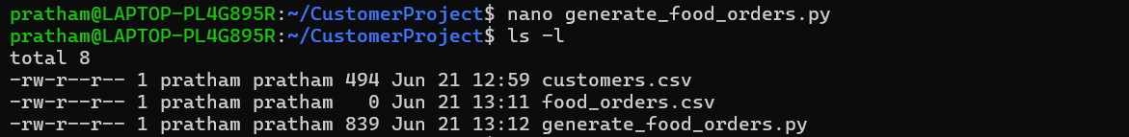

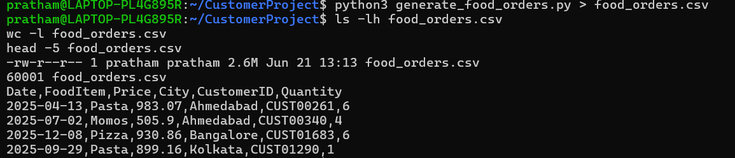

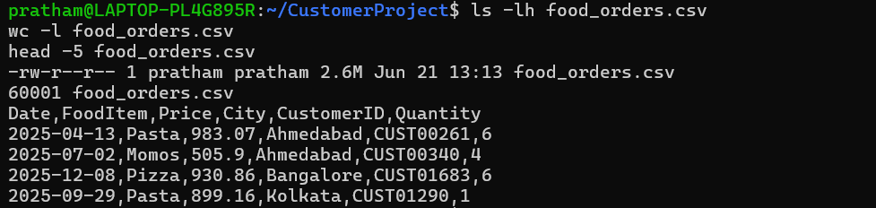

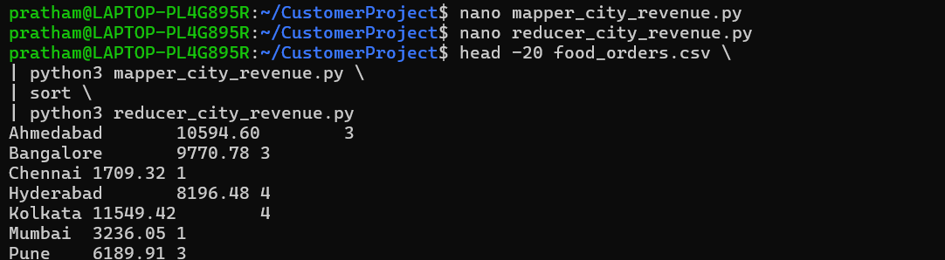

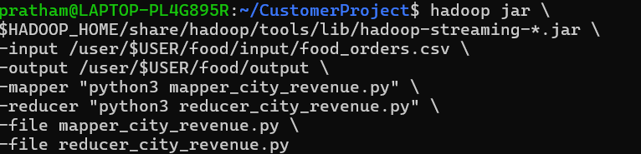

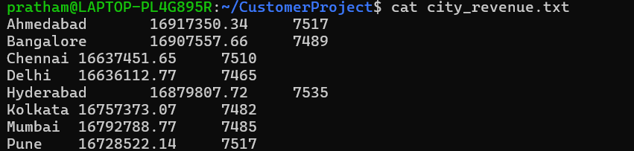

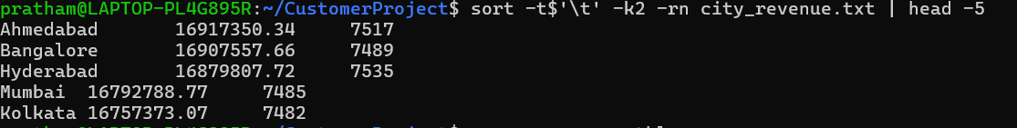

5. Conclusion
This project successfully demonstrates the use of Hadoop Streaming with Python MapReduce for processing large-scale food delivery data. A synthetic dataset containing thousands of food orders was generated and stored in HDFS. Using custom mapper and reducer programs, city-wise revenue, monthly sales trends, and product quantity analysis were performed efficiently. The results were further visualized using Python libraries such as Pandas and Matplotlib to derive meaningful business insights. Overall, the project highlights the practical application of Big Data Analytics, Hadoop Ecosystem, Python Programming, and Data Visualization for analyzing large datasets in a distributed environment.

